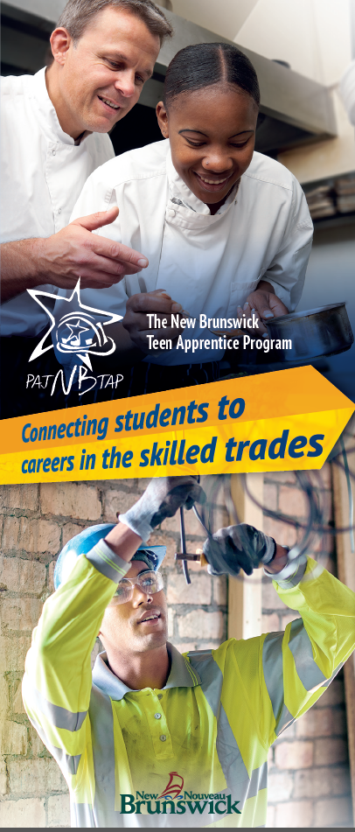
New Brunswick Teen Apprenticeship (NBTAP)
Summer Employment Opportunity

MILLWRIGHT / ELECTRICIAN / MACHINIST

Employer: ROGERS ELECTRIC AND MACHINE

Location: Bathurst

Competition Number: NBTAP:010-2023

Competition Closing Date: March 24, 2023

Pay Scale: For NBTAP Students – $16.00 per hour

If you have an interest in a career as a Millwright / Electrician or Machinist Technician, this position is for you. This is a unique opportunity to work with a highly skilled business in beautiful Bathurst, New Brunswick. Please ensure that you have transportation to arrive to and from work.

To apply for this position, send your resume and cover letter, with references to nbtap@gnb.ca

- Ensure your cover letter contains the Competition Number and Job Title for this opportunity.

- Provide three references with their full contact information (first and last name, email, and phone number)

- Indicate two other skilled trades areas of interest, to ensure that we might be able to accommodate you within another employment area, if unsuccessful.

Employer Information:

Rogers Electric & Machine is an ISO 9001 certified Electric Motor Repair Company with facilities in New Brunswick and Newfoundland & Labrador. Both facilities are capable of servicing electrical motors of all makes, models and sizes. Rogers has also developed as an expert in Compressed Air, Pumps and Equipment Sales & Service. With Field Service Technicians all over Atlantic Canada - They are the leader when it comes to industrial services. To learn more, visit their website at: https://www.rogerselectric.ca

The role of a Millwright/Electrician and Machinist consists of, but are not limited to:
- Uses personal protective equipment and maintains a safe work environment
- Perform lock-out and tag-out procedures
- Perform basic calibration of precision measuring instruments
- Read and transfer measurements from drawings
- Interpret basic hand signals, common symbols and markings found on drawings, and basic precision measuring instrument scales
- Uses hand and portable power tools; shop machines; access equipment; and fastening and retaining devices
- Install brackets, hangers, fasteners, seismic restrains systems (chains, cables, shock mounts), bonding systems, conductors, cables, and raceways

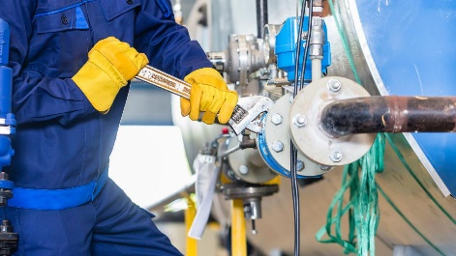
Qualifications:
- High school student in Grade 10 through to 12
      - Demonstrates initiative
      - Has effective problem-solving skills and is a team player
      - Reliable and dependable (Arrive to work when required and on-time)
      - Problem solving capabilities and effective hand-eye coordination
      - Willingness to learn new skills from a qualified mentor
      - Demonstrates customer service ability (Examples: polite, friendly, approachable)
      - A team player

Training: NBTAP Students will also be required to complete work ready sessions such as Respectful Workplace, Basic Tools, Safety and Employer Expectations arranged through the NBTAP coordinator prior to commencing employment. Also, employers may have orientation training required to be completed.

Employment Commencement Date: July 2, 2023 Employment Completion Date: August 28, 2023

If you require any assistance, please contact your NBTAP School Champion.
If you think this is an area of interest for you, please apply today!

