New Brunswick Teen Apprenticeship (NBTAP)
Summer Employment Opportunity

Landscape Horticulturalist
(Two Positions Available)

Employer: Price Landscaping Services

Location: Lutes Mountain, Moncton, NB

Competition Number: NBTAP:007-2023

Competition Closing Date: March 24, 2023

Pay Scale: For NBTAP Students – $14.00 - $14.50 per hour (depending on past experiences)

If you have an interest in a career as a Landscape-Horticulturalist, this position is for you. This is a unique opportunity to work with a highly skilled business in beautiful Lutes Mountain, New Brunswick. Please ensure that you have transportation to arrive to and from work.

To apply for this position, send your resume and cover letter, with references to nbtap@gnb.ca

- Ensure your cover letter contains the Competition Number and Job Title for this opportunity.

- Provide three references with their full contact information (first and last name, email, and phone number)

- Indicate two other skilled trades areas of interest, to ensure that we might be able to accommodate you within another employment area, if unsuccessful.
Employer Information:
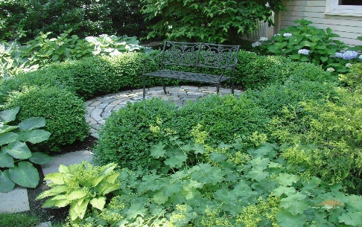
Price Landscaping Services has been in the landscape industry since 1968. Since that time, they have grown to employ over 40 talented and skilled full-time seasonal employees who continue to focus on quality service. They guarantee their work and have various warranty programs that they stand behind. In addition to the right people, they have the right equipment and expertise to help ensure a quality job. Their credentials include Landscape Industry Certified and Red Seal Landscape Horticulturalist Journey people. Some employees have achieved multiple designations. To learn more, visit their website at: https://pricelandscaping.ca

Qualifications:
- High school student in Grade 10 through to 12
      - Interested in the area of Landscaping Horticulture
      - A team player
      - Demonstrates effective hand-eye coordination
      - Reliable (showing up to work on-time and when required)
      - Committed to working hard and learning from a qualified mentor
      - Possess and understands the importance of effective time management skills
      - Uses effective communication and listening skills, including active listening skills
      - Demonstrates customer service ability (Examples: polite, friendly, approachable)

The role of a Landscape - Horticulturalist Secondary Pre-Apprentice consists of these duties, but are not limited to:
- Maintain all required equipment and work environment in a safe and effective manner
- Uses hand tools, vehicles, and motorized equipment
- Uses communication techniques
- Practices environmental and soil stewardship
- Installs growing media, mulch, sod, and turf from seed
- Transports materials and equipment
- Identifies plants and plant requirements
- Interact with the employer, mentor, co-workers, and general public
- Be a member of an effective workforce team

Training: NBTAP Students will also be required to complete work ready sessions such as Respectful Workplace, Basic Tools, Safety and Employer Expectations arranged through the NBTAP coordinator prior to commencing employment. Also, employers may have orientation training required to be completed.

Employment Commencement Date: July 2, 2023 Employment Completion Date: August 28, 2023

If you require any assistance, please contact your NBTAP School Champion.
If you think this is an area of interest for you, please apply today!

