New Brunswick Teen Apprenticeship (NBTAP)
Summer Employment Opportunity

HEAVY-DUTY EQUIPMENT TECHNICIAN

Employer: PETERBILT ATLANTIC

Location: Moncton

Competition Number: NBTAP:009-2023

Competition Closing Date: March 24, 2023

Pay Scale: For NBTAP Students – $16.50 per hour

If you have an interest in a career as a Heavy-Duty Equipment Technician, this position is for you. This is a unique opportunity to work with a highly skilled business in beautiful Moncton, New Brunswick. Please ensure that you have transportation to arrive to and from work.

To apply for this position, send your resume and cover letter, with references to nbtap@gnb.ca

- Ensure your cover letter contains the Competition Number and Job Title for this opportunity.

- Provide three references with their full contact information (first and last name, email, and phone number)

- Indicate two other skilled trades areas of interest, to ensure that we might be able to accommodate you within another employment area, if unsuccessful.
Employer Information:

Peterbilt Atlantic is an authorized Peterbilt dealership serving five provinces in Eastern Canada. They are proud to carry a large selection of new and pre-owned inventory. When customers are ready to invest in a new truck, their friendly and knowledgeable sales, financing, service, and parts departments are prepared to make sure their experience is outstanding, from assisting while they are making a choice to ongoing maintenance and customization. They value the opportunity to create a long-term relationship with their customers, and they do that by giving the best customer service available. Peterbilt Atlantic is the region's fastest growing full-line truck dealer and service centre, and the exclusive provider of Peterbilt products here in Atlantic Canada. Peterbilt Atlantic employs more than 160 people throughout New Brunswick, Nova Scotia, Newfoundland, Prince Edward Island and Quebec. To learn more, visit their website at: https://www.peterbiltatlantic.com

The role of a Heavy-Duty Equipment Technician consists of, but are not limited to:
- Maintains and uses lifting, rigging and hoisting equipment
- Services fasteners, sealing devices, adhesives, gaskets, hoses, tubing, piping, bearings, and seals
- Uses personal protective equipment and maintains a safe work environment
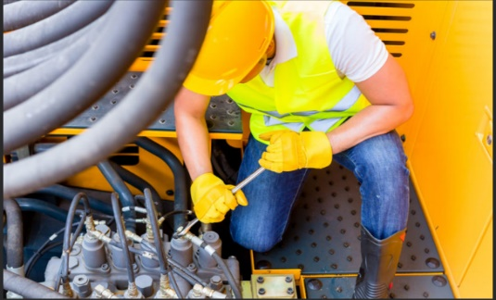
- Performs scheduled maintenance and pre-operational check
- Heats, cools, cuts, and welds materials
- Diagnoses and repairs brake systems and wheel assemblies
- Reads diagnostic trouble codes and identifies operational faults
- Interaction with the employer, mentor, co-workers, and general public
- Be a member of an effective workforce team

Qualifications:
- High school student in Grade 10 through to 12
      - Interest in skilled trades in the area of Heavy-Duty Equipment Technician
      - Demonstrates imitative
      - Has effective problem-solving skills and is a team player
      - Reliable and dependable (Arrive to work when required and on-time)
      - Demonstrate analytical thinking
      - Demonstrates customer service ability (Examples: polite, friendly, approachable)
      - Willingness to learn new skills from a qualified mentor

Training: NBTAP Students will also be required to complete work ready sessions such as Respectful Workplace, Basic Tools, Safety and Employer Expectations arranged through the NBTAP coordinator prior to commencing employment. Also, employers may have orientation training required to be completed.

Employment Commencement Date: July 2, 2023 Employment Completion Date: August 28, 2023

If you require any assistance, please contact your NBTAP School Champion.
If you think this is an area of interest for you, please apply today!

